***Shrimp Shrimp Chicken***

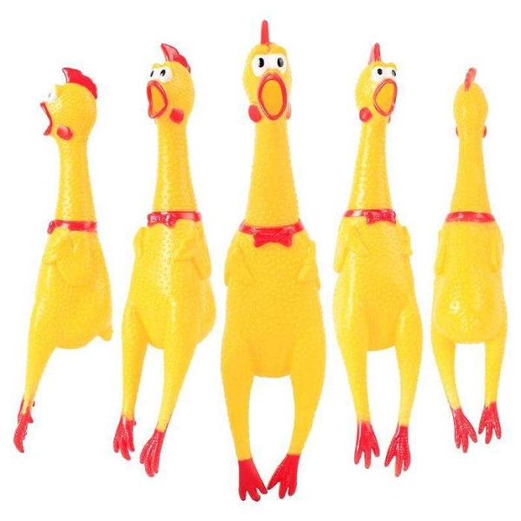

*Shrrilling Chicken is one of the hot products. It is loved by many young people. Chicken is made of plastic material, yellow color. When squeezed, it makes a very loud and funny sound. The product is very suitable as a gift for children, friends, or trolling others.*